

**CYPRUS**

**INTERNATIONAL UNIVERSITY.**

* **Department of Vocational School Computer Programming**
* **Software Engineering**
* **Project**

Topic- “Sales Management System”

|  |  |  |
| --- | --- | --- |
| Student No. | Name & Surname | Team No. |
| 20152074 | 20152074 | Team 2 |
| 21909164 | MICHEL NYEMBO CHUNGU | Team 2 |
| 21909488 | BENJAMIN BIN KAYA NGOY | Team 2 |
| 21911496 | LEON NGOY MWILAMBWE | Team 2 |

**Presented to** – Dr Kian

Contents

ABSTRACT 1

Introduction 2

Advantages: 2

Disadvantages: 2

Modules: 3

User Login/Registration 3

User Dashboard 3

Sales 4

Customer 6

Purchase 7

Supplier 9

Supplier 11

Payment 16

Report 18

Database 19

Project Lifecycle: 20

Description 20

How to run the project 21

Hardware Requirement: 21

Software Requirements 21

Installation/Configuration Steps 21

Database Configuration: 21

Run/Execute PHP Projects 21

References 22

**SALES MANAGEMENT SYSTEM**

**Software Engineering project**

# ABSTRACT

For the sale/purchase organization, sales management was created. This system keeps track of the consumer, supplier, the product, the sales order, and the purchase order. It gives traders a platform to automate their record-keeping. The goal of this project is to create an application software that will reduce manual labor in inventory, product, customer, dealer, and order management. This project was created to assist the administrator in the management of his company. Customer information can be saved in the database by the administrator. When the customer returns, there is no need to re-enter his information. It can be chosen from a drop-down menu that lists all clients. Then there is no need to enter his details again. It can be selected from the list displaying all customers.

# Introduction

As previously stated, a 'Sales Information System' is generic software that may be used by any trade organization to manage inventory. This is a project that is completely dynamic. In this project, the user creates a master record of all the things that the company sells or buys. Similarly, all reusable general records, such as city, state, and product unit, are recorded once in the database as master records. The user can then use these records for billing and purchase entries in the future. This makes the task more manageable and efficient. The user can begin purchasing and charging after completing the majority of the general master record entries. This has a purchase module for entering item purchases. The user enters the purchased item's name, quantity, and supplier, as well as saving the record. Similarly, there is a sale module for billing, where the user can enter details of the company's complete transaction. In this program, we keep track of client and supplier information in a master record for future reference. We have two more masters for employing these two masters: customer master and dealer master.

## Advantages:

• Saves time of user.

• It keeps track of customer service details.

• Fast and accurate.

• Provide better service to the customer.

## Disadvantages:

* This app has been developed in a short time, there were not enough time to check if everything is working perfectly

# Modules:

## User Login/Registration

Here the admin can login with his credentials on the webApp.

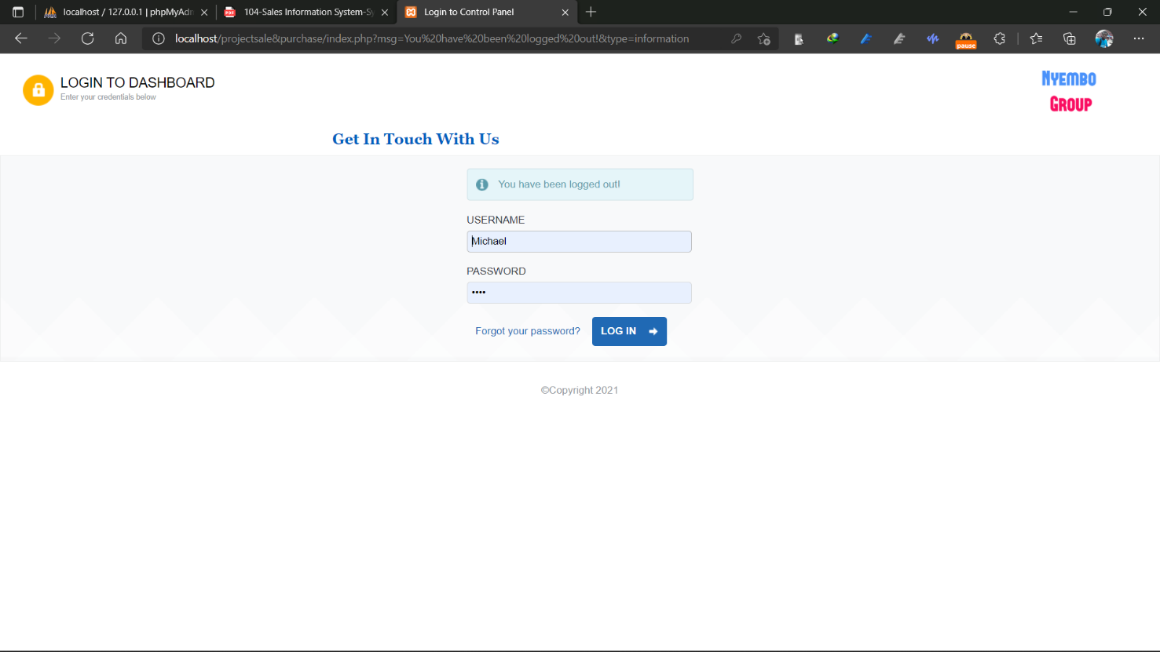

## User Dashboard

From the dashboard the admin will see the stock information and the statics of all the web app.

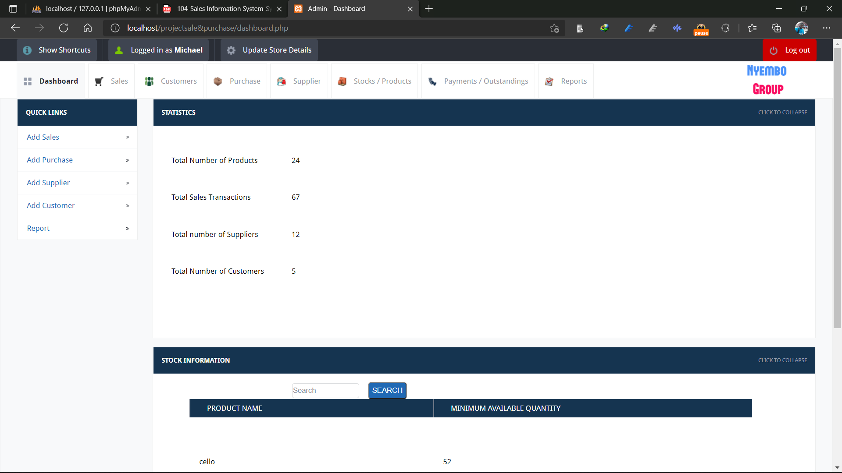

## Sales

Sales page contains Sales record(view) on the same page we can search, delete and even edit the list content and add sales where we can create new sale

**Sales record(view)**

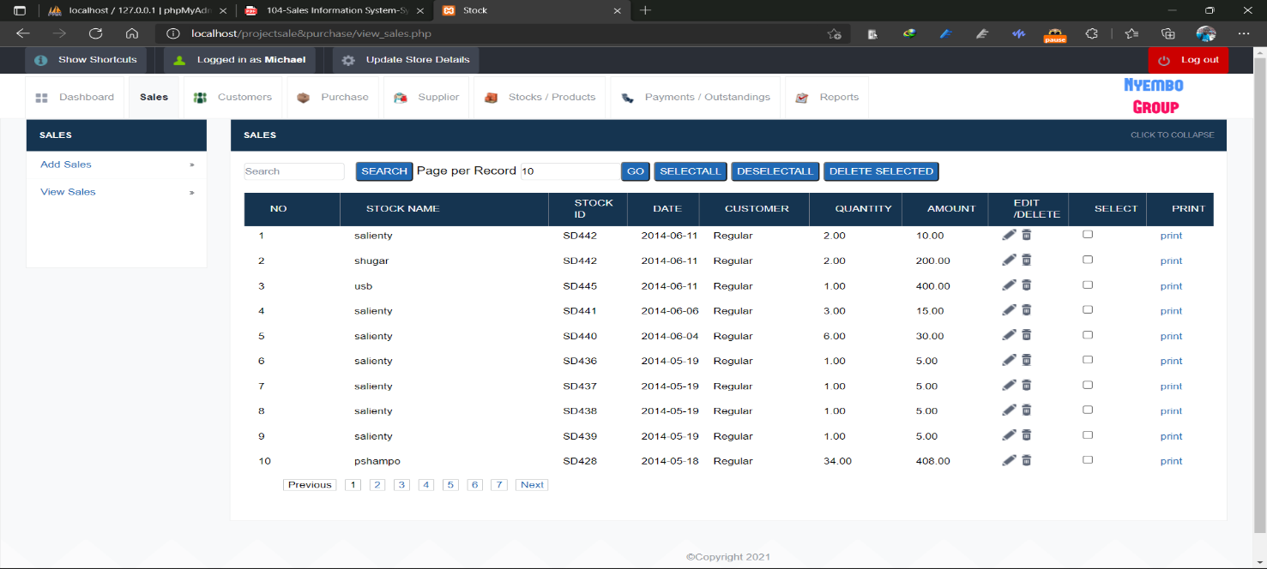

**Add sales**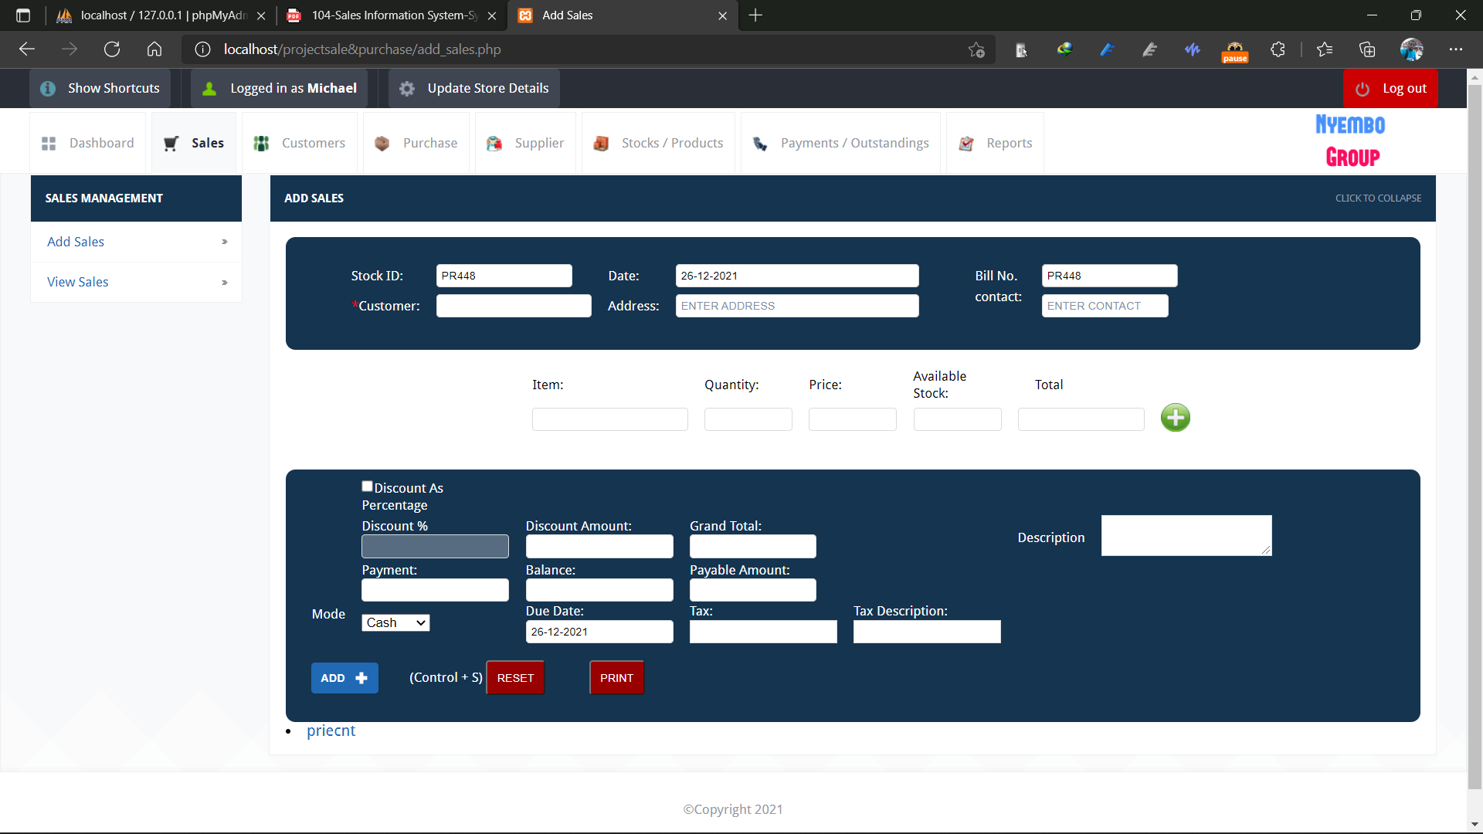

## Customer

Customer page contains a list of all customer(view) on the same page we can search, delete and even edit the list content and add Customer where we can create new customer

**Customer list (view)**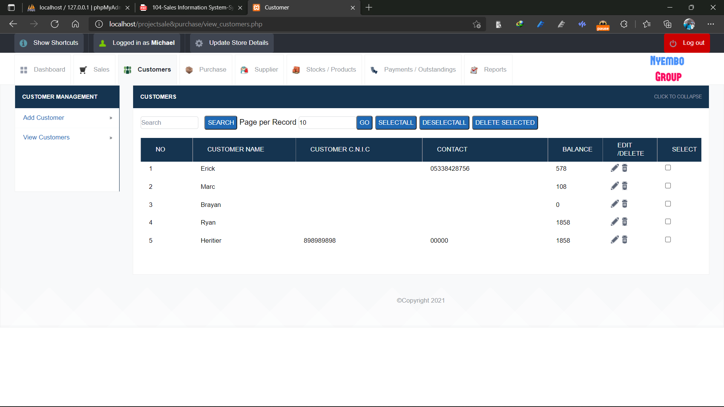

**Add new Customer**

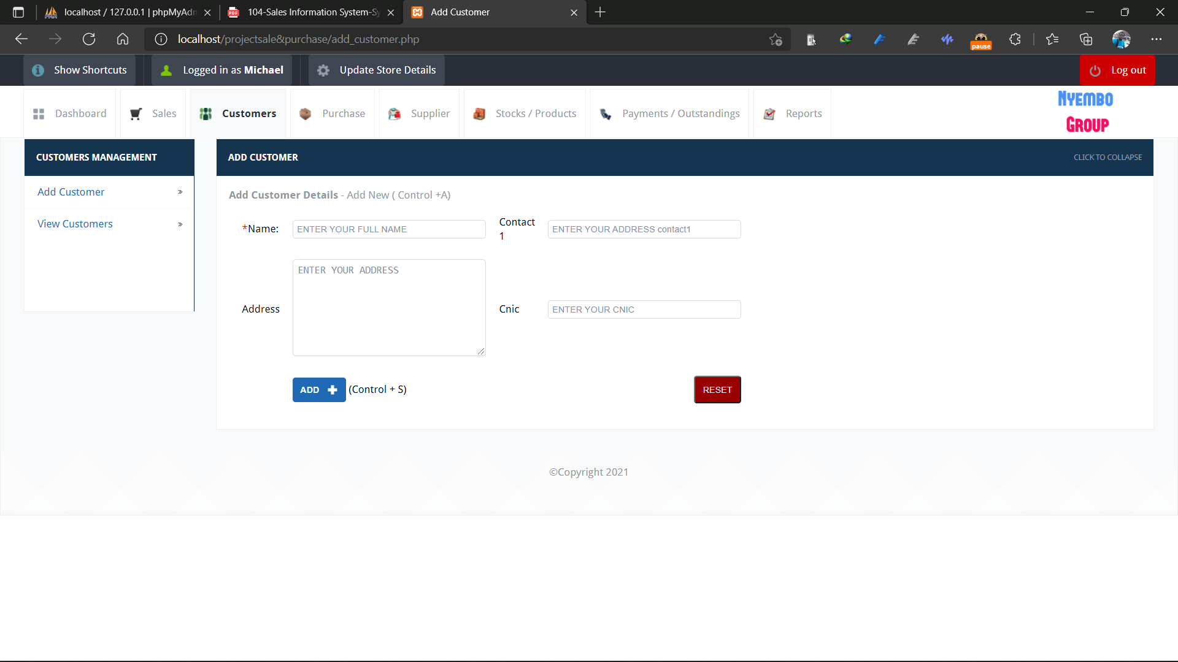

## Purchase

Purchase page contains a list of all purchase(view) on the same page we can search, delete and even edit the list content and add Purchases where we can create new purchase

**Purchase list(view)**

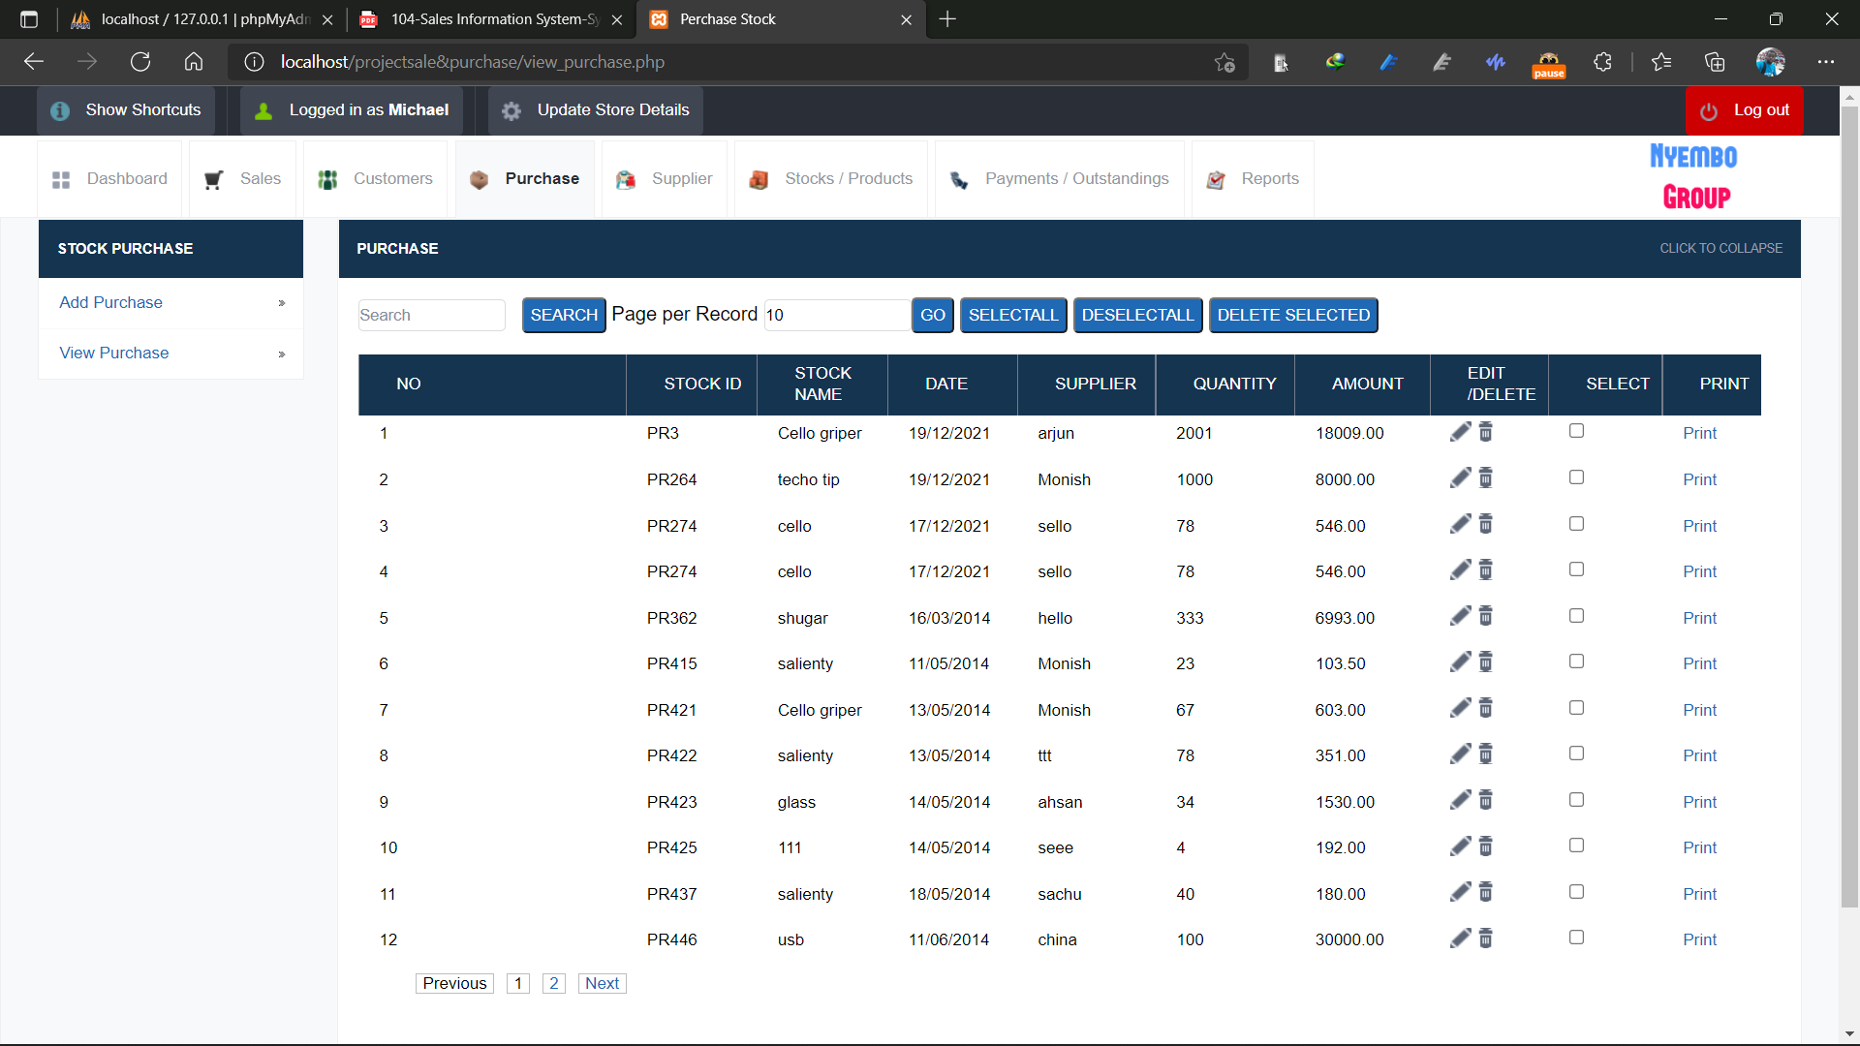

**Add Purchase**

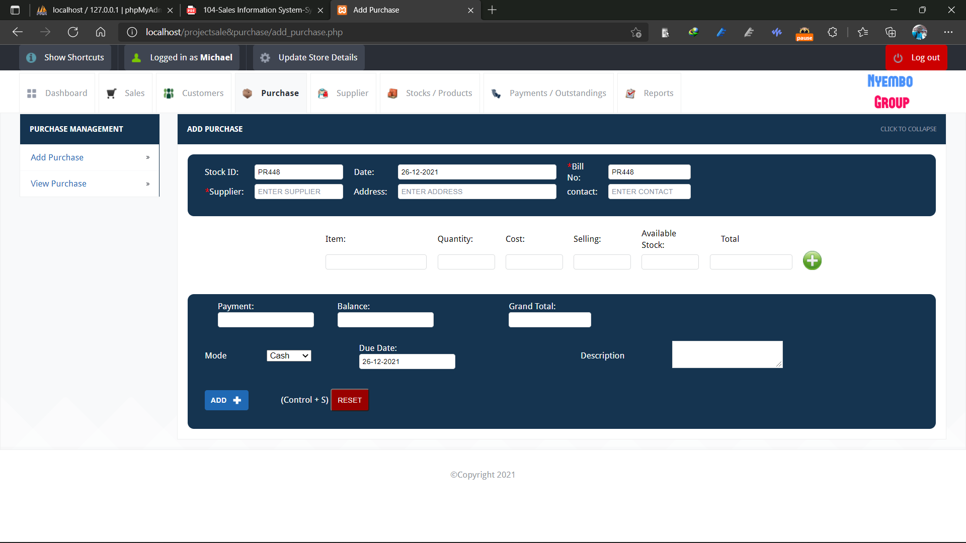

## Supplier

Supplier page contains a list of all purchase(view), on the same page we can search, delete and even edit the list content and add Supplier where we can create new purchase

**Supplier list(view)**

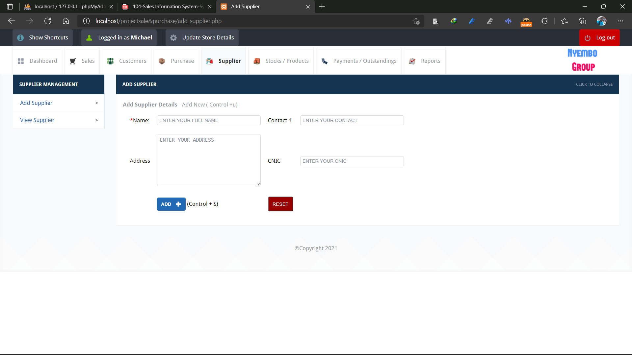

**Add 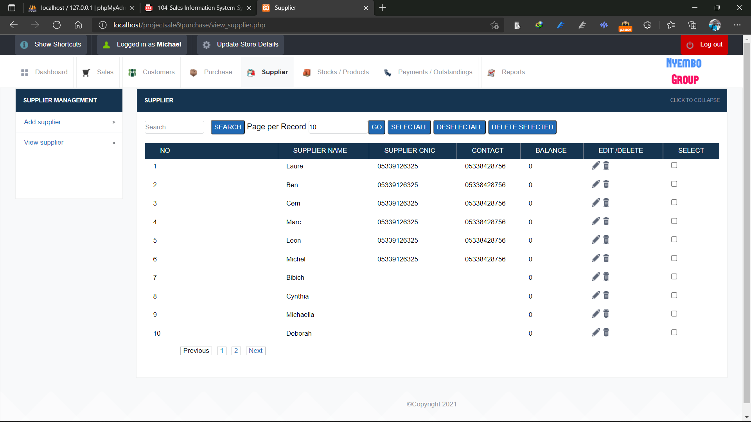Supplier**

## Supplier

Stock/Product page contains a list of product and category(view), on the same page we can search, delete and even edit the list content and add Category and product where we can create new category or product, then there is Stock available page where we can see the available stock

**Product list(view)**

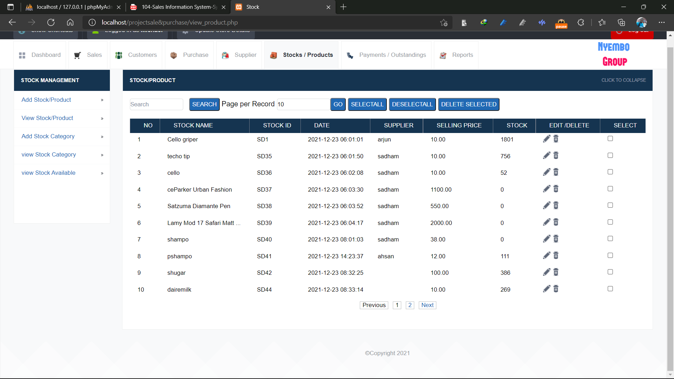

**Category list(view)**

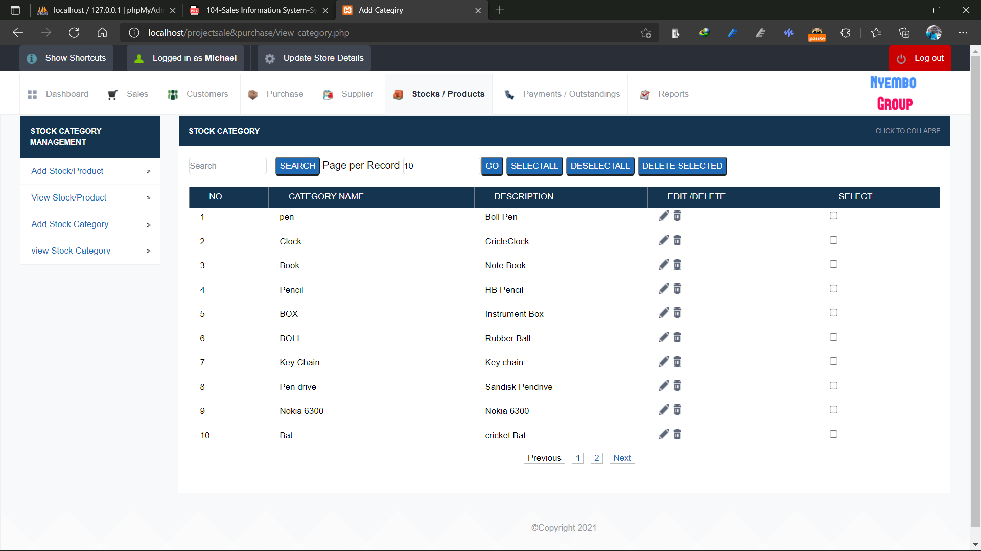

**Add Product**

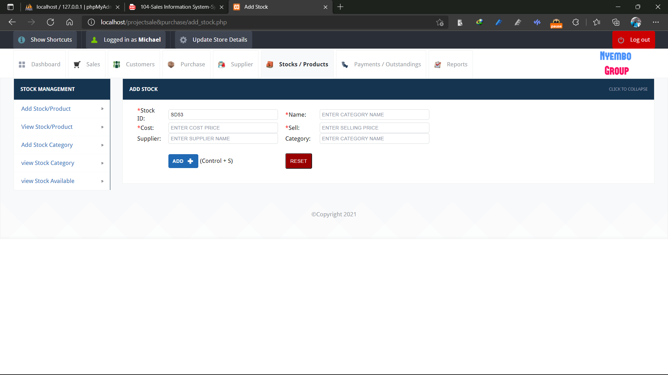

**Add Category**

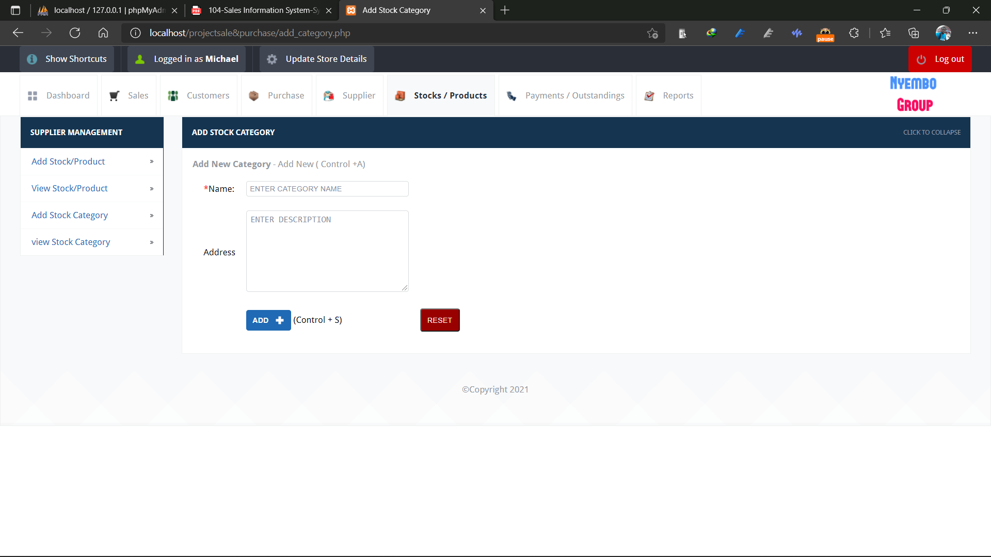

**Category Available**

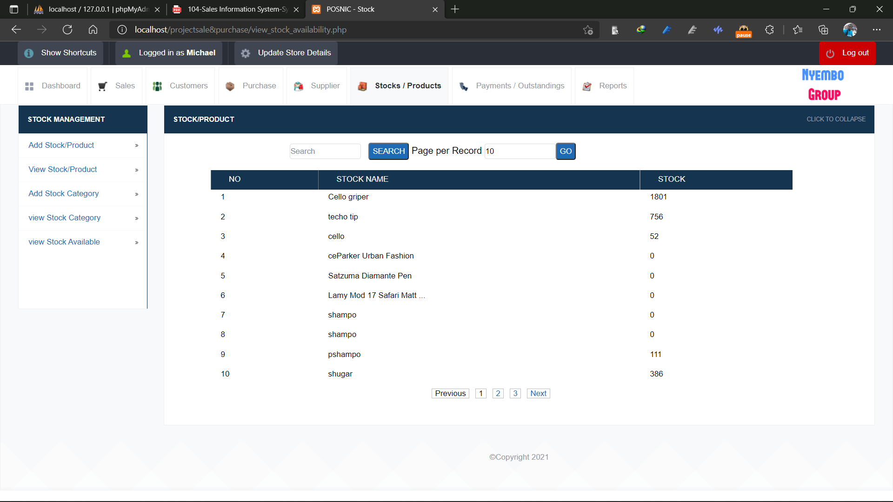

## Payment

On payment page there is the payment page and the outstanding payment page

**Payment**

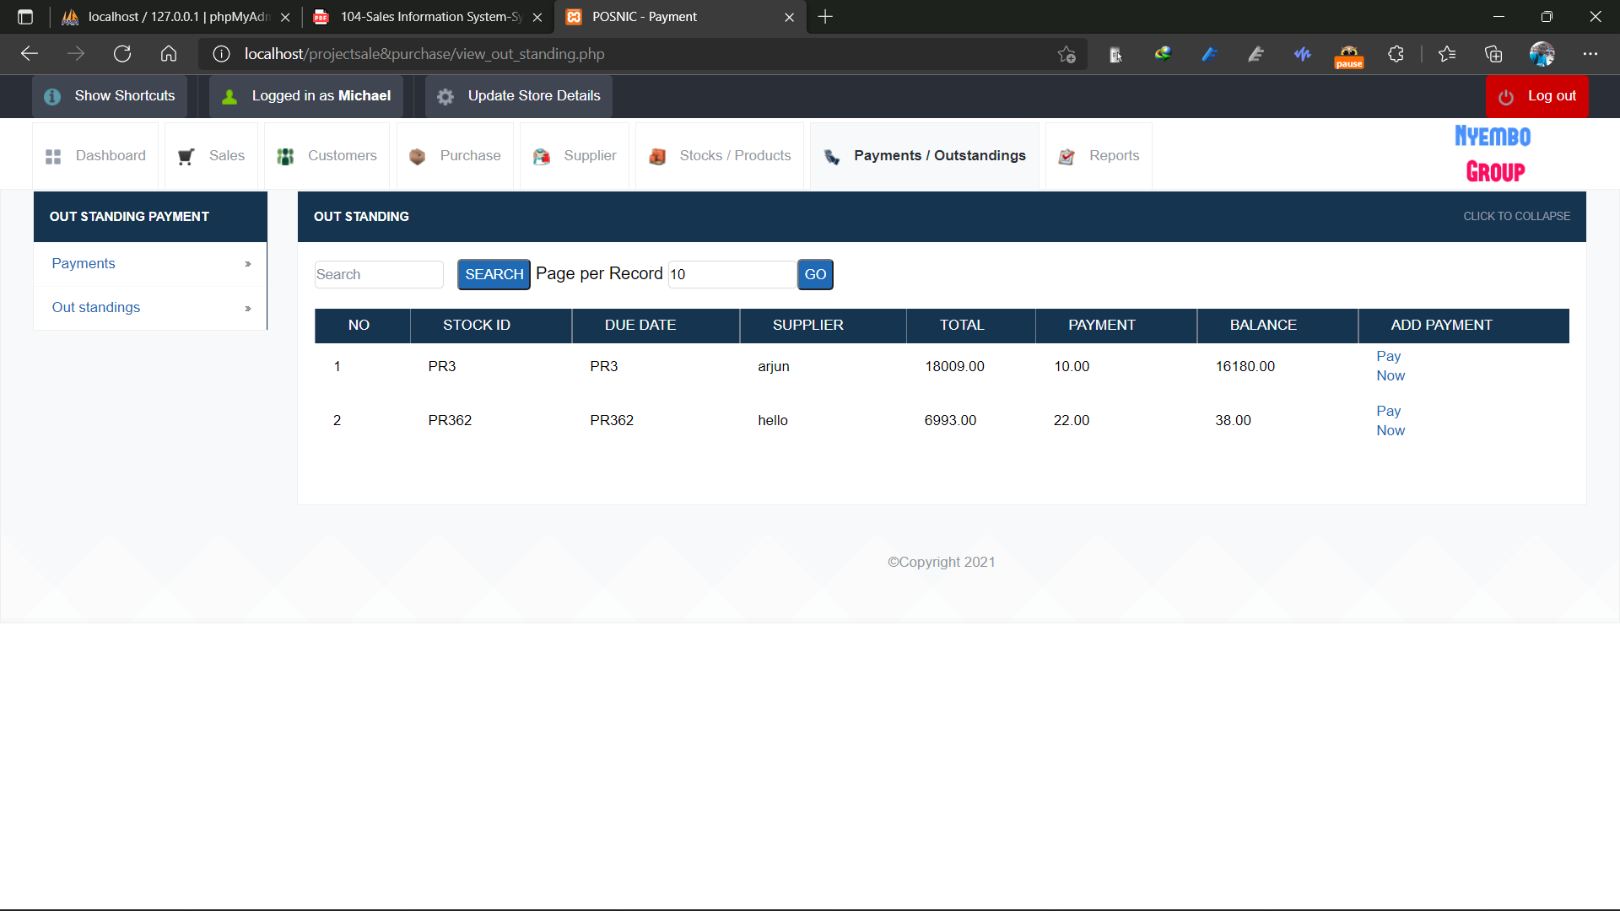

**Outstanding payment**

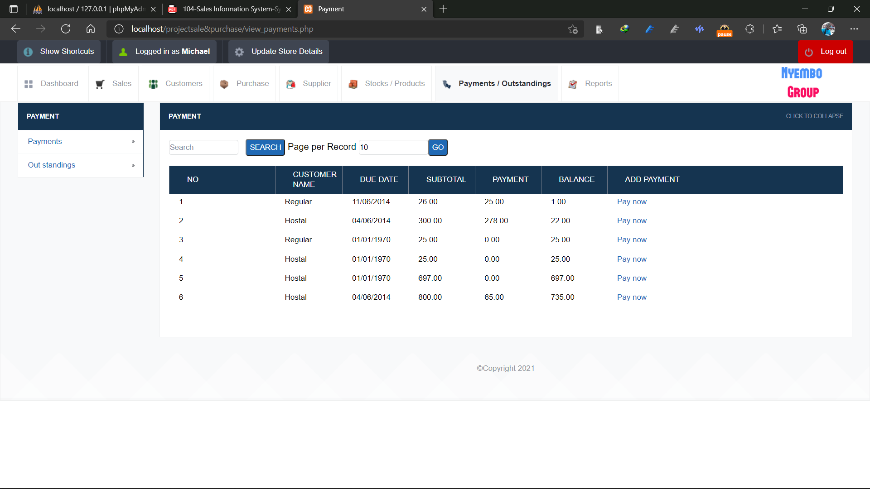

## Report

On the report page the admin can generate report of specific date and print it

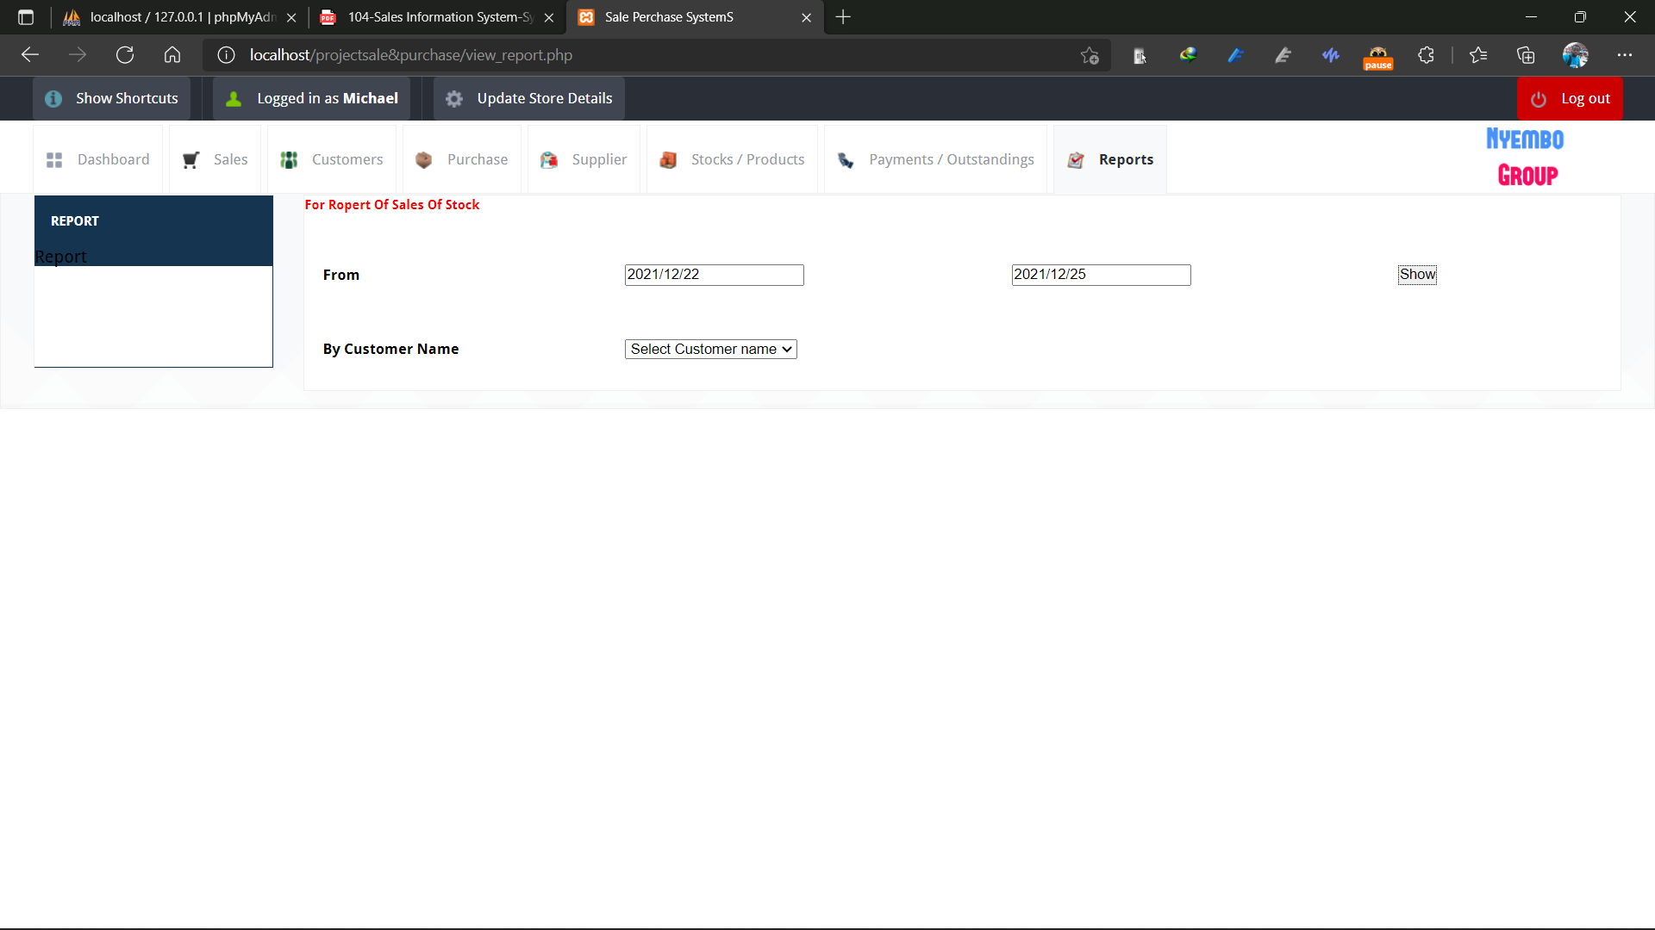

# Database

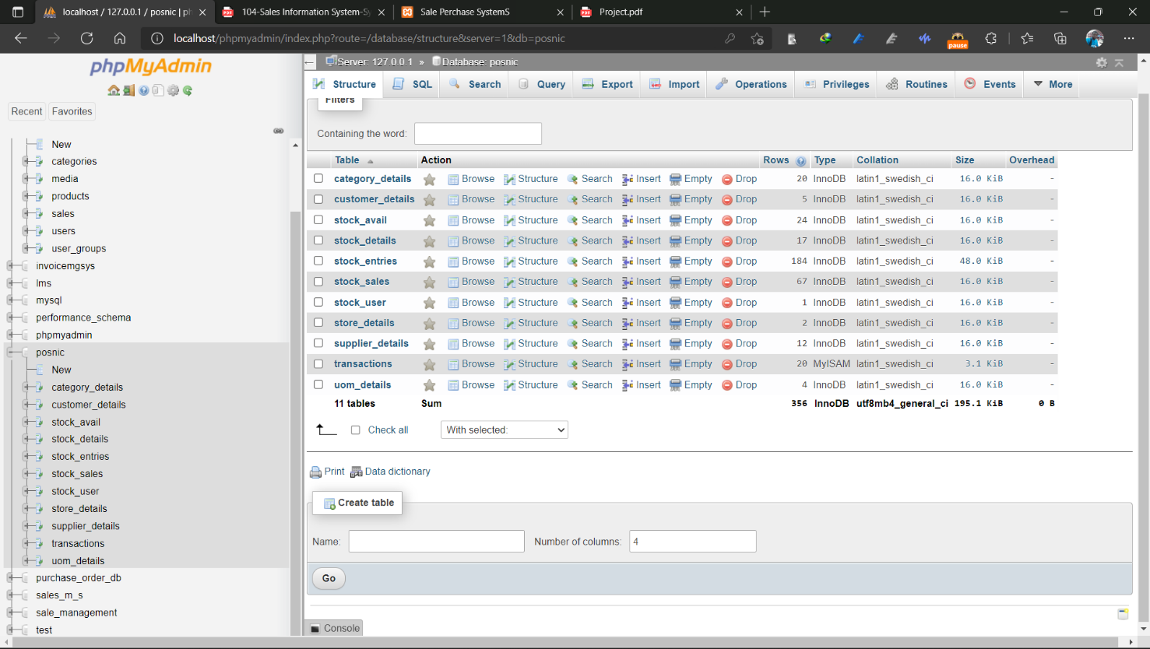

# Project Lifecycle:

## Description

The waterfall Model is a linear sequential flow. In which progress is seen as flowing steadily downwards (like a waterfall) through the phases of software implementation. This means that any phase in the development process begins only if the previous phase is complete. The waterfall approach does not define the process to go back to the previous phase to handle changes in requirement.

The waterfall approach is the earliest approach that was used for software development.

# How to run the project

## Hardware Requirement:

i3 Processor Based Computer or higher

Memory: 1 GB

Hard Drive: 50 GB

Monitor

Internet Connection

## Software Requirements

* WAMP Server
* XAMPP Server

## Installation/Configuration Steps

* Download zip files and Unzip files.
* Copy and Paste the unzip files inside c:/wamp/www/ or c:/xampp/htdocs/.

## Database Configuration:

Create a new database named posnic.

Import database posnic.sql file through phpMyAdmin dashboard

## Run/Execute PHP Projects

Open Your Web Browser preferable Google Chrome Browser

Put/type inside the web browser : localhost/project folder

# References

https://www.phpmyadmin.net/docs/ https://www.w3schools.com/php/DEFAULT.asp

https://stackoverflow.com/ https://developer.mozilla.org/en-US/docs/Web/JavaScript https://www.google.com/

https://www.youtube.com/